TECHNICAL SUPPORT DOCUMENT
2017 BASELINE SUMMERTIME OZONE EMISSIONS INVENTORY:
NON-ROAD WELL PAD CONSTRUCTION EQUIPMENT
OPERATING WITHIN THE OIL AND GAS FIELDS
WITHIN THE UINTAH, UT NONATTAINMENT AREA

MARCH 2020
Utah Division of Air Quality
Planning Branch/Mobile Sources

Abstract

This report discusses the non-road well pad construction equipment 2017 baseline summertime ozone emissions inventory for equipment operating within the shale gas and conventional oil fields in the Uintah, UT Non-Attainment Area (NA).

Non-road equipment activity was provided by: March 2016 Ramboll Environ Colorado Air Resource Management Modeling Study (CARMMS) with updated Mancos Shale Modeling CARMMS 1.5 Final Report: appendix C-2 and C-4. Shale gas and conventional oil well pad construction activities include: pad, access road, and pipeline construction. Non-road equipment inventories were calculated using emission factors generated by the EPA MOVES2014b Non-Road Model (Motor Vehicle Emission Simulator) utilizing the movesdb20181022 default database. 2017 well counts were provided for by the DAQ Technical Analysis Section from the Utah Division of Oil, Gas, and Mining.

Summary Table for the 2017 Non-road well pad construction equipment inventory is located on page 9.

3.) NON-ROAD WELL PAD CONSTRUCTION EQUIPMENT INVENTORY

i. Table of Contents……………………………………………………………………......... 3
ii. Overview………………………………………………………………………................. 4
iii Emission Factors………………………………………………………………………..... 4

iv. Emissions Calculations ….................................................................................................... 8

v. References………………………………………………………..….................................... 10

LIST OF TABLES

Table 1: Emission Factors……………………………………………………………... 6
Table 2: 2016 Ramboll Environ CARMMS 1.5 Final Report Appendix C2 Shale Gas
Calculator Inputs by Source Category: Well Pad, Access Road, Pipeline
Construction (p C-49)…………………………………………………………………. 7

Table 3: 2016 Ramboll Environ CARMMS 1.5 Final Report Appendix C4
Conventional Oil Well Calculator Inputs by Source Category: Well Pad, Access
Road, Pipeline Construction (p C-73)…………………………………………............... 8
Table 4: Utah Division of Oil, Gas, and Mining 2017 Spud count……………………. 8

Table 5: 2017 MOVES2014b Non-Road Well Pad Construction Equipment
Inventory Emissions Tons Per Year for Duchesne & Uintah County…………………. 9

ii. Overview

The purpose of this document is to explain the emissions modeling assumptions used to develop the 2017 baseline summertime ozone emissions inventory for non-road well pad construction equipment operating within the oil and gas fields in the Uintah, UT Non-Attainment Area.

Agencies that developed the 2017 baseline for the Uintah Basin, UT Ozone NA:
Utah Division of Air Quality (UDAQ)

iii. Emissions Factors

The following procedures were used to develop emission factors:

- Emission Factor Development
Non-road well pad construction equipment was identified within the March 2016 Ramboll Environ Colorado Air Resource Management Modeling Study (CARMMS) with updated Mancos Shale Modeling CARMMS 1.5 Final Report¹. Appendix C-2 and C-4 was used exclusively to identify well pad construction equipment, hours of operation, and days of operation for shale gas and conventional oil development. MOVES (Motor Vehicle Emission Simulator) Non-Road default emission factors were developed for these pieces of equipment using the EPA approved MOVES2014b Non-Road model. MySQL was used to select pieces of equipment by county and Source Classification Code (SCC) for equipment that equaled 300 Horse Power (HP). The emission factors developed from MOVES are in grams per operating hour by SCC by HP. This was accomplished by dividing the default daily emissions by the default daily hours of operation see Table 1.

- The following local inputs were used within MOVES

Fuel:
An adjustment was made for 2017 to account for gasoline sulfur level in Utah since small volume refiners are not required to comply with federal Tier 3 gasoline (10 ppm sulfur) requirements until January 1, 2020. EPA Office of Transportation and Air Quality (OTAQ) provided 2017 local gasoline sulfur values of 20.9 ppm. MOVES 2014a default fuel parameters were used for diesel and CNG. Since the non-road equipment being modeled is primarily diesel equipment this change should have no impact on the modeling result but the input is consistent with the fuel parameters being used for on-road mobile emissions.

Meteorological Data:

The UDAQ Technical Analysis Section provided metrological conditions from multiple meteorological sites located throughout the state of Utah from Meso West data archives. Meso West (mesowest.utah.edu) is a database of current and archived meteorological data from weather stations in the United States maintained by the University of Utah. The meteorological data is an hourly average temperature and relative humidity from ozone conditions from the month of July in 2017.

iv. Emissions Inventory

The emissions inventory was derived by multiplying the grams per hour by SCC (Table1) by the total number hours of operation by SCC indicated by the activity identified in the CARMMS report. The activity for shale gas wells was used from CARMMS Report Appendix C-49 see Table 2. The activity for conventional oil wells was used from CARMMS Report Appendix C-49 see Table 3. This provides an inventory for a single shale gas or conventional oil well. This number is then multiplied by the total number of well types that have been developed for 2017 according to Utah Division of Oil, Gas, and Mining see Table 4. The emissions are combined by SCC by county to create a non-road mobile source well pad construction equipment inventory see Table 5.

Table 1: Emission Factors
2017 MOVES2014b Non-Road Emission Factors Gm/(Op*Hr) for Duchesne County
Eq Description | SCC | HP Range | CO | NOx | NH3 | VOC | PM2.5 Total Exh
Grader | 2270-00-2048 | 300 | 52.932 | 163.899 | 0.594 | 9.491 | 9.043
Off-Highway Truck | 2270-00-2051 | 300 | 36.540 | 109.640 | 0.627 | 6.280 | 6.491
Tractor/Loader/Backhoe | 2270-00-2066 | 300 | 64.688 | 119.459 | 0.213 | 17.381 | 11.095
Crawler Tractor/Dozers | 2270-00-2069 | 300 | 54.613 | 169.056 | 0.605 | 9.898 | 9.335
Other Const Eq | 2270-00-2081 | 300 | 84.478 | 252.945 | 0.600 | 17.685 | 14.565
2017 MOVES2014b Non-Road Emission Factors Gm/(Op*Hr) for Uintah County
Eq Description | SCC | HP Range | CO | NOx | NH3 | VOC | PM2.5 Total Exh
Grader | 2270-00-2048 | 300 | 52.932 | 163.900 | 0.594 | 9.491 | 9.043
Off-Highway Truck | 2270-00-2051 | 300 | 36.540 | 109.640 | 0.627 | 6.280 | 6.491
Tractor/Loader/Backhoe | 2270-00-2066 | 300 | 64.688 | 119.459 | 0.213 | 17.381 | 11.095
Crawler Tractor/Dozers | 2270-00-2069 | 300 | 54.613 | 169.055 | 0.605 | 9.898 | 9.335
Other Const Eq | 2270-00-2081 | 300 | 84.478 | 252.943 | 0.600 | 17.685 | 14.565

Table 2: 2016 Ramboll Environ CARMMS 1.5 Final Report Appendix C2 Shale Gas Calculator Inputs by Source Category: Well Pad, Access Road, Pipeline Construction (p C-49)

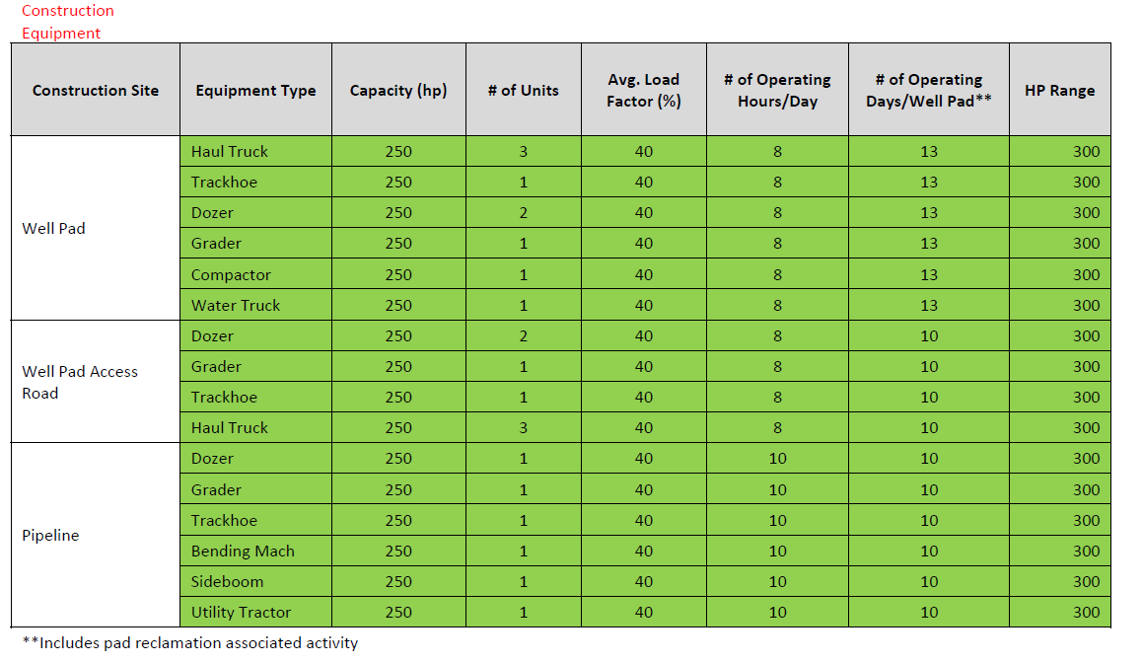

Table 3: 2016 Ramboll Environ CARMMS 1.5 Final Report Appendix C4 Conventional Oil Well Calculator Inputs by Source Category : Well Pad, Access Road, Pipeline Construction (p C-73)
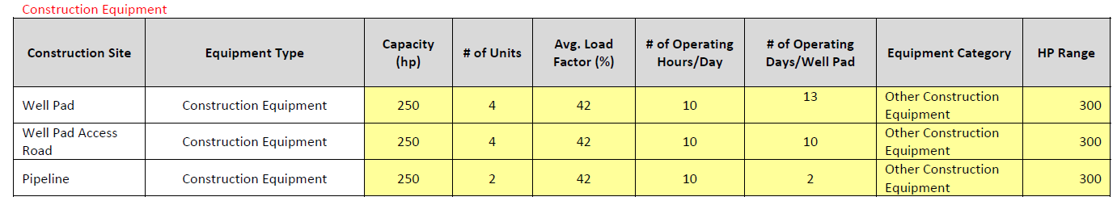

Table 4: Utah Division of Oil, Gas, and Mining 2017 Spud count
Utah Division of Oil, Gas, and Mining 2017 Spud count
Cal Yr | County | FIPs | Gas | Oil | Sum
2017 | DU | 49013 | 0 | 60 | 60
2017 | UI | 49047 | 2 | 84 | 86

Table 5: 2017 MOVES2014b Non-Road Well Pad Construction Equipment Inventory Emissions Tons Per Year for Duchesne & Uintah County

2017 MOVES2014b Non-Road Well Pad Construction Equipment Inventory Emissions Tons Per Year for Duchesne County
SCC | CO | NOx | NH3 | VOC | PM2.5 Total Exh
2270-00-2048 | 0.0000 | 0.0000 | 0.0000 | 0.0000 | 0.0000
2270-00-2051 | 0.0000 | 0.0000 | 0.0000 | 0.0000 | 0.0000
2270-00-2066 | 0.0000 | 0.0000 | 0.0000 | 0.0000 | 0.0000
2270-00-2069 | 0.0000 | 0.0000 | 0.0000 | 0.0000 | 0.0000
2270-00-2081 | 5.3638 | 16.0602 | 0.0381 | 1.1229 | 0.9248
Tons Per Year | 5.3638 | 16.0602 | 0.0381 | 1.1229 | 0.9248

2017 MOVES2014b Non-Road Well Pad Construction Equipment Inventory Emissions Tons Per Year for Uintah County
SCC | CO | NOx | NH3 | VOC | PM2.5 Total Exh
2270-00-2048 | 0.0331 | 0.1026 | 0.0004 | 0.0059 | 0.0057
2270-00-2051 | 0.0528 | 0.1586 | 0.0009 | 0.0091 | 0.0094
2270-00-2066 | 0.0548 | 0.1011 | 0.0002 | 0.0147 | 0.0094
2270-00-2069 | 0.0563 | 0.1744 | 0.0006 | 0.0102 | 0.0096
2270-00-2081 | 7.5659 | 22.6537 | 0.0538 | 1.5839 | 1.3045
Tons Per Year | 7.7630 | 23.1905 | 0.0558 | 1.6239 | 1.3386

v. Appendix: Baseline Year Inventories

Input files will be furnished upon request.

vi. References

- March 2016 Ramboll Environ Colorado Air Resource Management Modeling Study (CARMMS) with updated Mancos Shale Modeling CARMMS 1.5 Final Report

